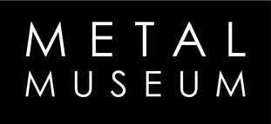
F.I.R.E. Rules and Regulations

1.) All participants are responsible for being present at appropriate times for their scheduled workshops, casting times and cleanup responsibilities.

2.) All participants are responsible for breaking the iron and coke required to fill their own molds, which includes molds from workshops, and molds made independently. If you are physically unable to break your own materials, you must make arrangements with the Museum staff prior to the beginning of the conference.

3.) All participants must respect the Museum grounds and the sculptures. No littering or damage may come to the property. Participants are responsible for cleaning personal work areas and respecting foundry tools and equipment.

4.) Balance of materials used must be paid in full before the materials will be released to the artist at their final departure from the conference.

5.) There will be no alcohol consumption permitted in the marked safety/work zones, or while the Museum is open to the general public. There will be no working while under the influence.

6.) All iron/coke breaking must be finished by 7pm on Friday evening. All mold making must be finished by 9pm Friday evening.

7.) All participants for the iron pour must be at the mandatory safety meeting on Saturday prior to the pour, and wear appropriate safety gear. All clothing must be natural fiber; with all leather shoes. If you are on a pour crew or furnace crew, full leathers (jacket, chaps, spats, gloves, safety glasses and face shield) are required. No exceptions.

8.) Reaction molds and foam vapor molds are not permitted.

