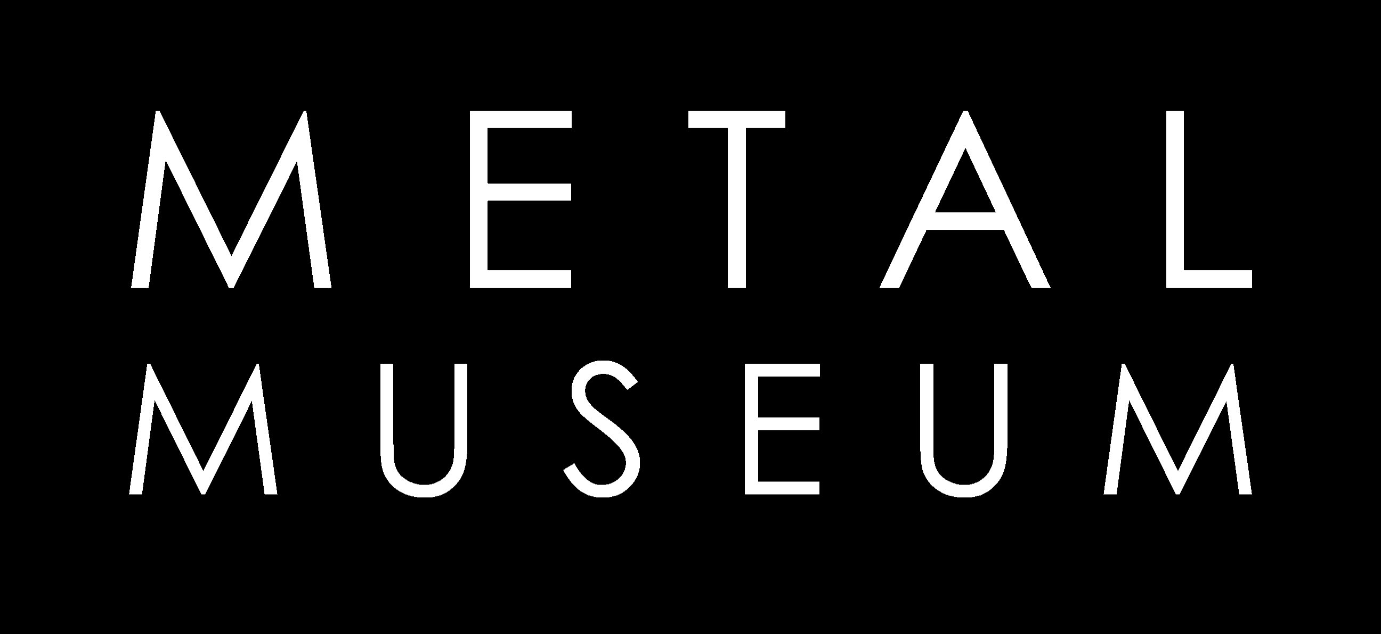

F.I.R.E. 2023 Pop-up Exhibition
(Everybody Gets In)
Saturday, May 20th

The Metal Museum would like to extend an opportunity for Conference participants to showcase personal work. All attendees are encouraged to submit one art piece for display during the Saturday of F.I.R.E. The Museum will supply labels for exhibit, and encourages artists to bring business cards, show cards and other supporting materials to display along with artwork.

For information on the Pop-up exhibition, please contact Savannah Smith at: savannah@metalmuseum.org for details.

Timeline: Exhibition will run during the Family Fun Day, Saturday, May 20th from 9:00 AM-6:00 PM

Artwork Restrictions: All work must be able to be displayed on a table, pedestal or floor and cannot exceed 16” in any direction. If hanging work is to be considered, display stand for attachment must be supplied by the artist. Artwork that may be considered offensive to the public will be removed.

Artwork Delivery: Delivery is the responsibility of the artist. Pieces may be brought the day before the show, or may be shipped the week prior. If shipping work, please attention the shipment to “fire exhibit”. All work must be delivered to the designated area at the Metal Museum by 9:00 AM on Friday, May 19th.

Liability: Insurance and liability is the responsibility of the artist. The Museum does not accept any liability for the artwork during transit, storage, installation or display and will not process insurance claims for any loss or damage.

*The Metal Museum reserves the right to remove artwork from the exhibition at anytime for any reason.

To enter an artwork in the exhibition, please submit an image and a completed form to Savannah Smith at: savannah@metalmuseum.org

